Eclipse setup:

1. Unzip eclipse eclipse-jee-mars-2-win32-x86_64
2. Add below properties at last in eclipse.ini file from D:\mastering-ci\tools\eclipse-jee-mars-2-win32-x86_64\eclipse

-Dorg.eclipse.ecf.provider.filetransfer.excludeContributors=org.eclipse.ecf.provider.filetransfer.httpclient4

-Dorg.eclipse.ecf.provider.filetransfer.retrieve.closeTimeout=3000

-Dorg.eclipse.ecf.provider.filetransfer.retrieve.readTimeout=3000

3. check whether JDK exists in the system

4. Set JAVA_HOME as “C:\Program Files\Java\jdk1.7.0_79”

And set path as “%JAVA_HOME%\bin” in user variables.

5. Open eclipse Mars

**NOTE**: While opening eclipse if it is showing as java version is not compatible , set below property in eclipse.ini file.

-vm

C:\Program Files\Java\jdk1.7.0_79\bin\javaw.exe

6. Modify the Network Connections as below.

**Host url:** inhydwbs02-wcg.corp.capgemini.com

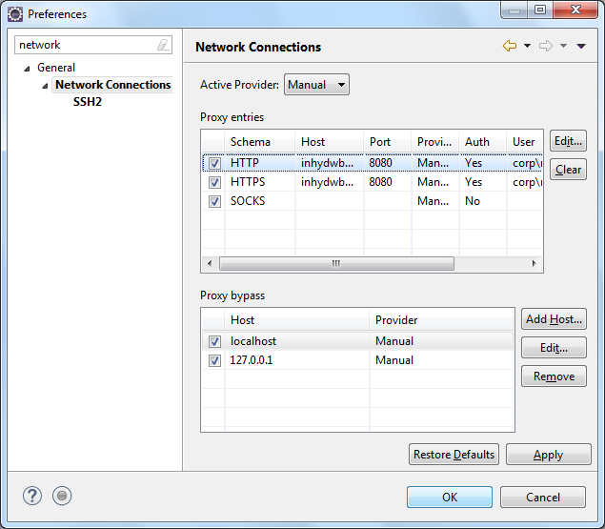

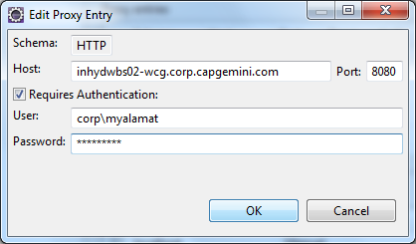

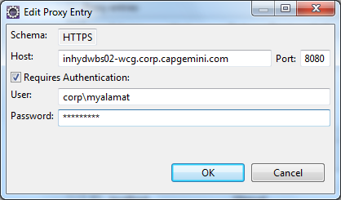

7. Install below plugins into eclipse

**1. Bulidship Plugin url:** <http://download.eclipse.org/buildship/updates/e45/releases/1.0>

2. Subclipse Plugin url: <http://subclipse.tigris.org/update_1.10.x>

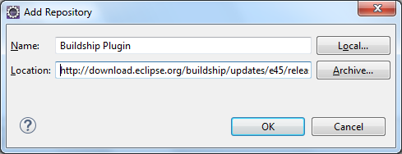

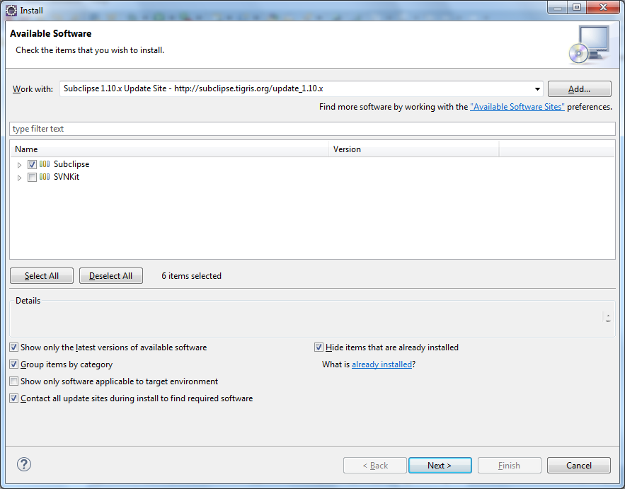

8. Create a gradle project in eclipse

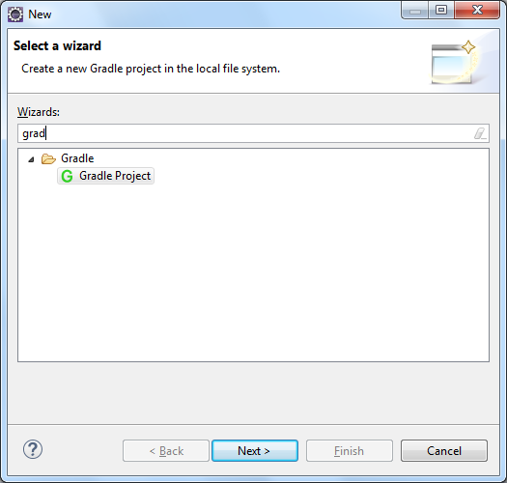

9. Change the Gradle Distribution to Local installation directory and spcify the path.

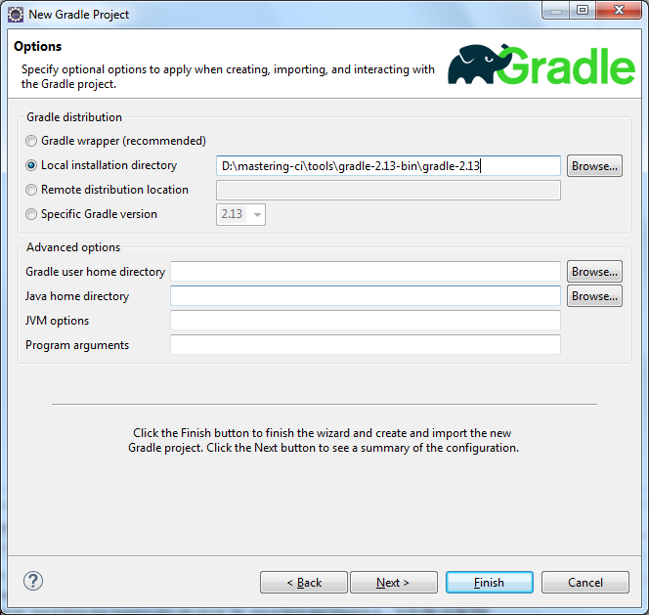

10. Update below property in “org.eclipse.buildship.core.prefs” file

connection.gradle.distribution=GRADLE_DISTRIBUTION(LOCAL_INSTALLATION(D:\\mastering-ci\\tools\\gradle-2.13-bin\\gradle-2.13))

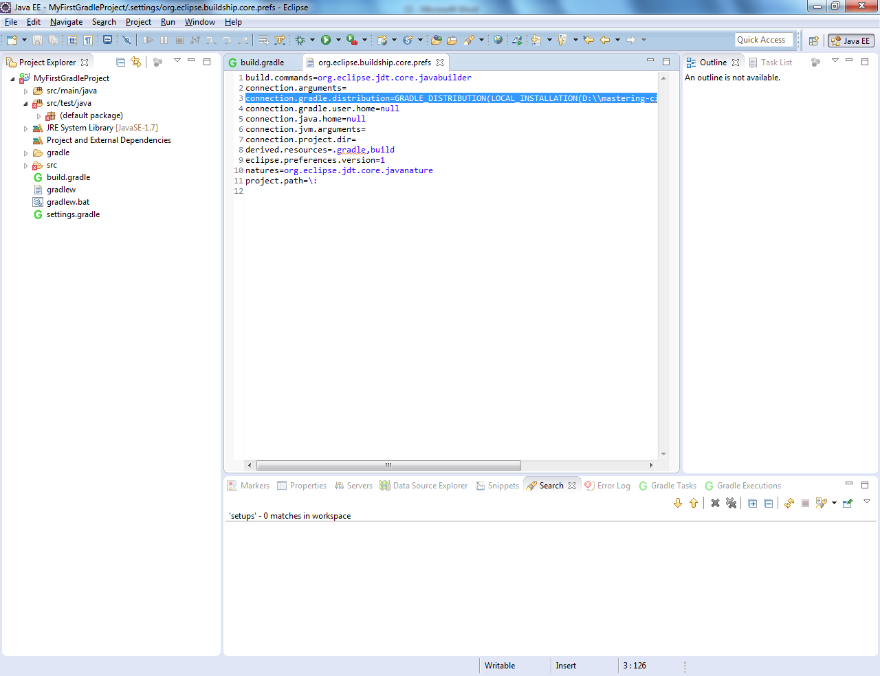

11. Refresh Gradle Project to resolve errors.

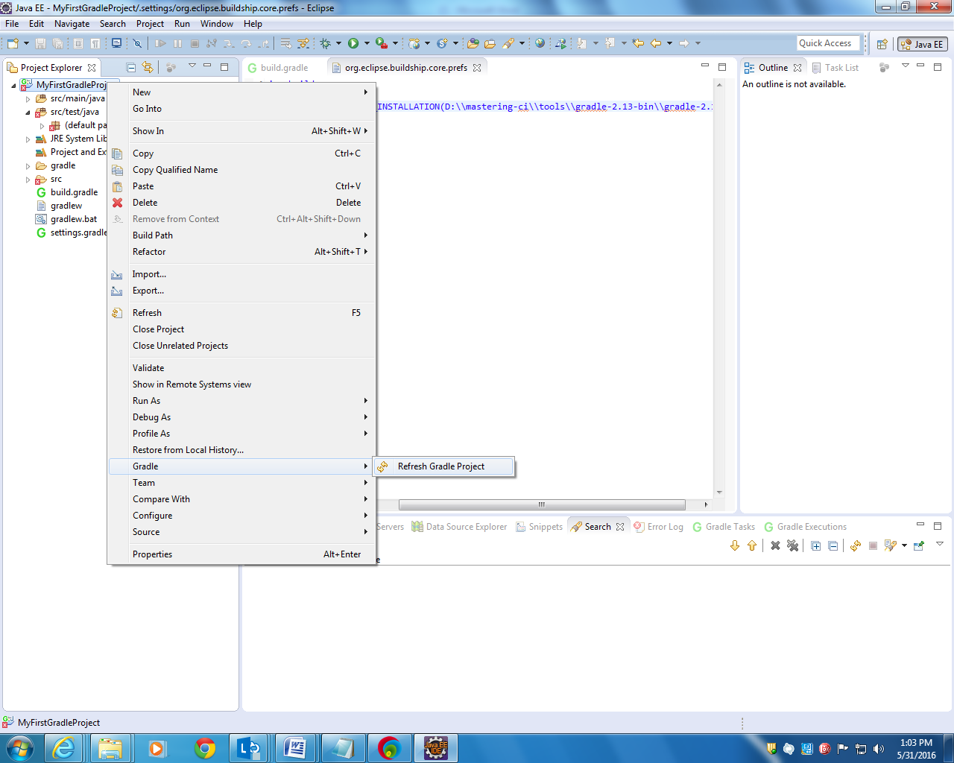

12. To check in the project into SVN

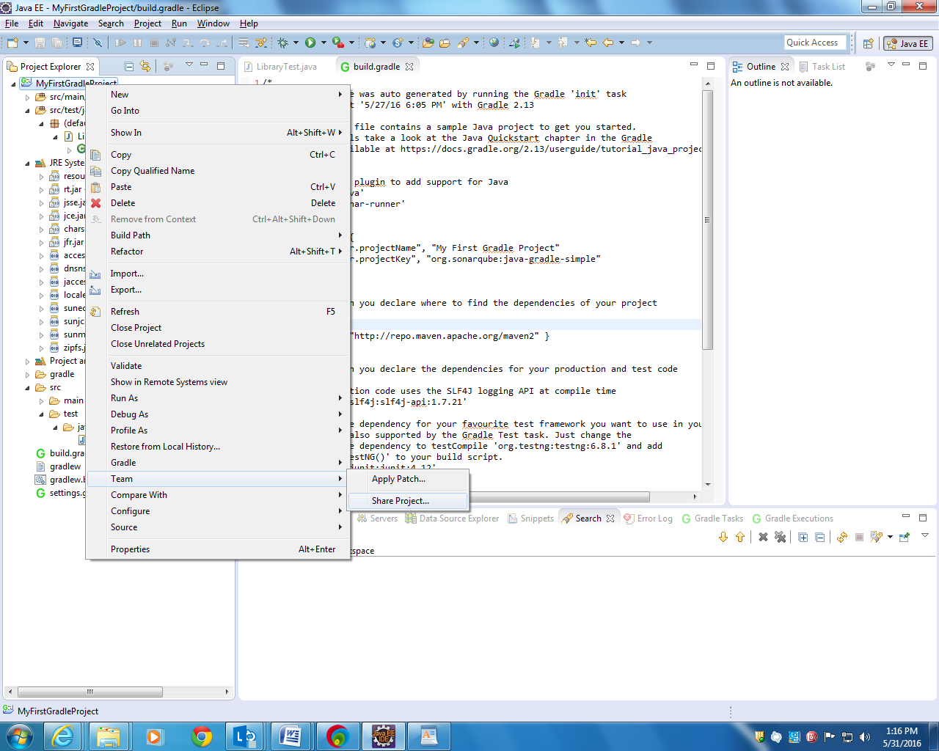

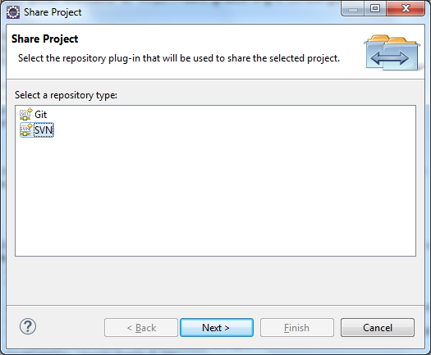

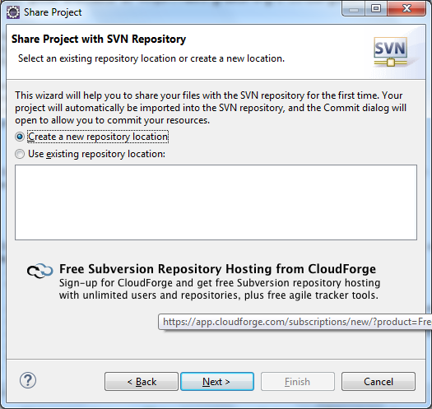

Specify the repository location that was already created in Visual SVN server.

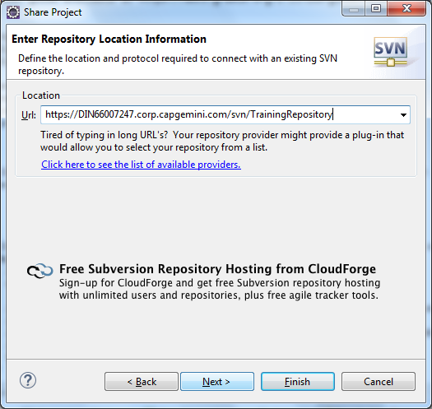

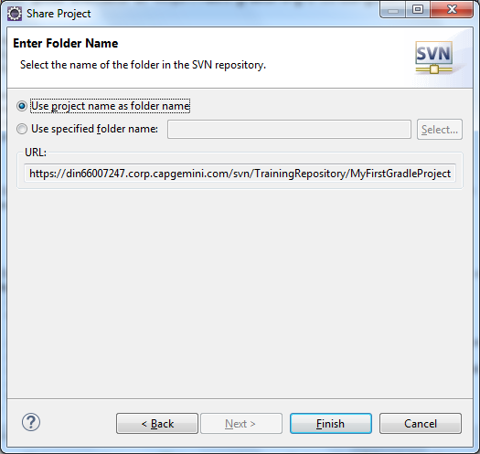

To commit the changes, go to Synchronize with repository.

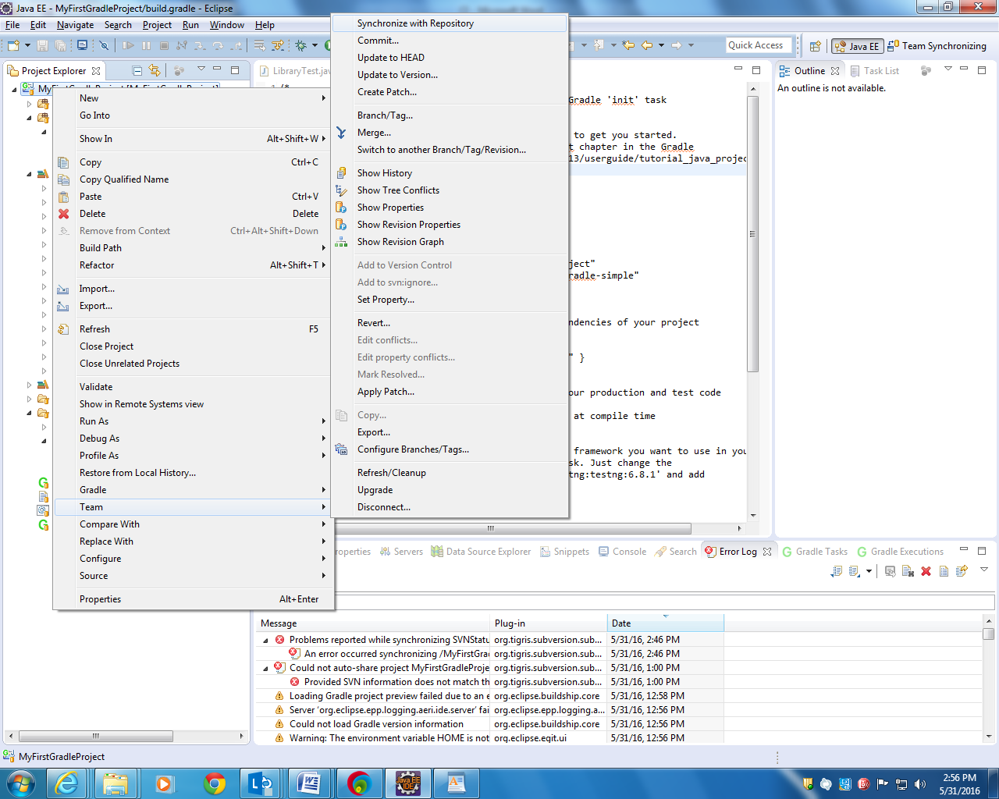

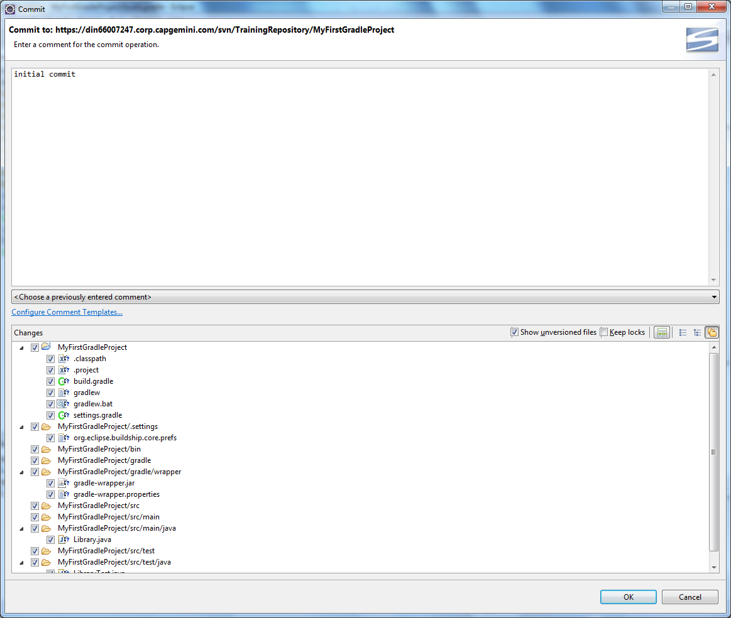

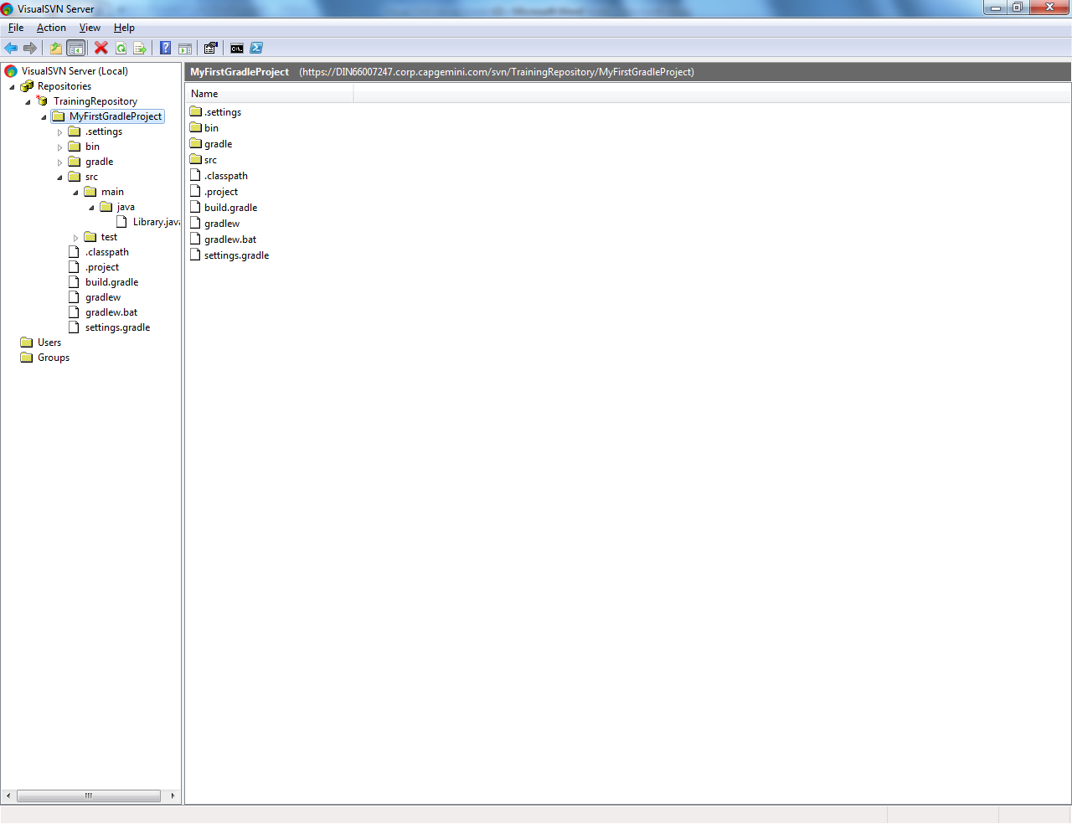

**Jenkins:**

1. To Start Jenkins, go to Jenkins war location in command prompt and enter

“D:\mastering-ci\tools>javac -jar jenkins.war --httpPort=9999”

If we have two Java versions(java 1.6 and 1.7), below error may occur.

D:\mastering-ci\tools>java -jar jenkins.war --httpPort=9999

Jenkins requires Java7 or later, but you are running 1.6.0_45-b06 from C:\Progra

m Files\Java\jre6

java.lang.UnsupportedClassVersionError: 50.0

at Main.main(Main.java:90)

**To resolve this:**

D:\mastering-ci\tools>path

PATH=C:\WINDOWS\system32;C:\WINDOWS;C:\WINDOWS\System32\Wbem;C:\WINDOWS\System32

\WindowsPowerShell\v1.0\;C:\Program Files (x86)\QuickTime\QTSystem\;C:\Program F

iles\CapgeminiScripts\Support Tools\;C:\Program Files\VisualSVN Server\bin;C:\Pr

ogram Files\Java\jdk1.7.0_79\bin

D:\mastering-ci\tools>set JAVA_HOME=C:\Program Files\Java\jdk1.7.0_79

D:\mastering-ci\tools>set **path=%JAVA_HOME%\bin**

D:\mastering-ci\tools>java -jar jenkins.war --httpPort=9999

Running from: D:\mastering-ci\tools\jenkins.war

webroot: $user.home/.jenkins

May 31, 2016 4:13:51 PM winstone.Logger logInternal

INFO: Beginning extraction from war file

May 31, 2016 4:13:53 PM org.eclipse.jetty.util.log.JavaUtilLog info

INFO: jetty-winstone-2.9

May 31, 2016 4:13:55 PM org.eclipse.jetty.util.log.JavaUtilLog info

INFO: NO JSP Support for , did not find org.apache.jasper.servlet.JspServlet

Jenkins home directory: D:\Users\slc\.jenkins found at: $user.home/.jenkins

May 31, 2016 4:13:56 PM org.eclipse.jetty.util.log.JavaUtilLog info

INFO: Started SelectChannelConnector@0.0.0.0:9999

May 31, 2016 4:13:56 PM winstone.Logger logInternal

INFO: Winstone Servlet Engine v2.0 running: controlPort=disabled

May 31, 2016 4:13:56 PM jenkins.InitReactorRunner$1 onAttained

INFO: Started initialization

May 31, 2016 4:14:11 PM jenkins.InitReactorRunner$1 onAttained

INFO: Listed all plugins

May 31, 2016 4:14:11 PM jenkins.InitReactorRunner$1 onAttained

INFO: Prepared all plugins

May 31, 2016 4:14:11 PM jenkins.InitReactorRunner$1 onAttained

INFO: Started all plugins

May 31, 2016 4:14:11 PM jenkins.InitReactorRunner$1 onAttained

INFO: Augmented all extensions

May 31, 2016 4:14:13 PM jenkins.InitReactorRunner$1 onAttained

INFO: Loaded all jobs

May 31, 2016 4:14:14 PM hudson.model.AsyncPeriodicWork$1 run

INFO: Started Download metadata

May 31, 2016 4:14:15 PM org.jenkinsci.main.modules.sshd.SSHD start

INFO: Started SSHD at port 55168

May 31, 2016 4:14:15 PM jenkins.InitReactorRunner$1 onAttained

INFO: Completed initialization

May 31, 2016 4:14:15 PM jenkins.InitReactorRunner$1 onAttained

INFO: Started initialization

May 31, 2016 4:14:15 PM jenkins.InitReactorRunner$1 onAttained

INFO: Listed all plugins

May 31, 2016 4:14:15 PM jenkins.InitReactorRunner$1 onAttained

INFO: Prepared all plugins

May 31, 2016 4:14:15 PM jenkins.InitReactorRunner$1 onAttained

INFO: Started all plugins

May 31, 2016 4:14:15 PM jenkins.InitReactorRunner$1 onAttained

INFO: Augmented all extensions

May 31, 2016 4:14:15 PM jenkins.InitReactorRunner$1 onAttained

INFO: Loaded all jobs

May 31, 2016 4:14:15 PM jenkins.InitReactorRunner$1 onAttained

INFO: Completed initialization

May 31, 2016 4:14:15 PM hudson.WebAppMain$3 run

INFO: Jenkins is fully up and running

May 31, 2016 4:14:24 PM hudson.model.UpdateSite updateData

INFO: Obtained the latest update center data file for UpdateSource default

←[33mMay 31, 2016 4:14:45 PM hudson.model.DownloadService$Downloadable updateNow

WARNING: Could not load json from http://updates.jenkins-ci.org/updates/hudson.t

asks.Maven.MavenInstaller.json

java.net.ConnectException: Connection timed out: connect

at java.net.DualStackPlainSocketImpl.connect0(Native Method)

at java.net.DualStackPlainSocketImpl.socketConnect(DualStackPlainSocketI

mpl.java:79)

at java.net.AbstractPlainSocketImpl.doConnect(AbstractPlainSocketImpl.ja

va:339)

at java.net.AbstractPlainSocketImpl.connectToAddress(AbstractPlainSocket

Impl.java:200)

at java.net.AbstractPlainSocketImpl.connect(AbstractPlainSocketImpl.java

:182)

at java.net.PlainSocketImpl.connect(PlainSocketImpl.java:172)

at java.net.SocksSocketImpl.connect(SocksSocketImpl.java:392)

at java.net.Socket.connect(Socket.java:579)

at java.net.Socket.connect(Socket.java:528)

at sun.net.NetworkClient.doConnect(NetworkClient.java:180)

at sun.net.www.http.HttpClient.openServer(HttpClient.java:432)

at sun.net.www.http.HttpClient.openServer(HttpClient.java:527)

at sun.net.www.http.HttpClient.<init>(HttpClient.java:211)

at sun.net.www.http.HttpClient.New(HttpClient.java:308)

at sun.net.www.http.HttpClient.New(HttpClient.java:326)

at sun.net.www.protocol.http.HttpURLConnection.getNewHttpClient(HttpURLC

onnection.java:997)

at sun.net.www.protocol.http.HttpURLConnection.plainConnect(HttpURLConne

ction.java:933)

at sun.net.www.protocol.http.HttpURLConnection.connect(HttpURLConnection

.java:851)

at sun.net.www.protocol.http.HttpURLConnection.getInputStream(HttpURLCon

nection.java:1301)

at hudson.model.DownloadService.loadJSONHTML(DownloadService.java:188)

at hudson.model.DownloadService$Downloadable.updateNow(DownloadService.j

ava:402)

at hudson.PluginManager.doCheckUpdatesServer(PluginManager.java:987)

at jenkins.model.DownloadSettings$DailyCheck.execute(DownloadSettings.ja

va:118)

at hudson.model.AsyncPeriodicWork$1.run(AsyncPeriodicWork.java:99)

at java.lang.Thread.run(Thread.java:745)

←[0m←[33mMay 31, 2016 4:14:45 PM hudson.model.DownloadService$Downloadable updat

eNow

WARNING: No tool installer metadata found for hudson.tasks.Maven.MavenInstaller

←[0mMay 31, 2016 4:14:47 PM hudson.model.DownloadService$Downloadable load

INFO: Obtained the updated data file for hudson.tasks.Ant.AntInstaller

May 31, 2016 4:14:49 PM hudson.model.DownloadService$Downloadable load

INFO: Obtained the updated data file for hudson.tools.JDKInstaller

May 31, 2016 4:14:49 PM hudson.model.AsyncPeriodicWork$1 run

INFO: Finished Download metadata. 34,777 ms